2006 England and France Vacation
June 6th, 2006 to June 24th , 2006

Sunday | Monday | Tuesday | Wednesday | Thursday | Friday | Saturday
 |  | 6th  Leave Denver | 7th  ^{Land in London}  ^{Bonnington Hotel} | 8th  ^{Leave London}  ^{for Lincoln}  ^{Bailhouse} | 9th  ^{Lincoln}  ^{Bailhouse} | 10th  ^{Leave for York}  ^{23, St. Mary’s}
11th  ^{York}  ^{23, St. Mary’s} | 12th  ^{Leave for London}  ^{Bonnington Hotel} | 13th  Leave London for Paris via Chunnel.  ^{Bersoly’s} | 14th  ^{Paris}  ^{Bersoly’s}  ^{Rouen Day Trip} | 15th  Leave Paris for Amboise via Train.  ^{Hotel La Breche} | 16th  ^{Amboise}  ^{Hotel La Breche} | 17th  ^{Amboise}  ^{Hotel La Breche}
18th  ^{Amboise}  ^{Hotel La Breche} | 19th  ^{Amboise}  ^{Hotel La Breche} | 20th  ^{Leave for Paris via Train.}  ^{Bersoly’s} | 21st  ^{Paris}  ^{Bersoly’s} | 22nd  ^{Leave Paris for}  ^{London via Chunnel}  ^{Holiday Inn} | 23rd  ^{London}  ^{Holiday Inn} | 24th  Leave London

Legend: Leave/Arrive, Overnight Stay

June 6th (Tuesday) – leave Denver at 8:40PM on Flight BA218
June 7th (Wednesday) – arrive at London – Heathrow at 12:45PM, stay at Bonnington.
June 8th (Thursday) – Hertz rental car by 10AM for trip to Lincoln, stay at Bailhouse
June 9th (Friday) – Lincoln sights.
June 10th (Saturday) – Leave for York, 23 St. Mary’s B&B.
June 11th (Sunday) – York, 23 St. Mary’s B&B, visit sights around York up north.
June 12th (Monday) – Drive to London from York, stay at Bonnington.
June 13th (Tuesday) – Leave for Paris via Chunnel, stay at Bersoly’s.
June 14th (Wednesday) – Spend day in Paris, stay at Bersoly’s.

June 15th (Thursday) – TGV train to St. Pierre de Corps, stay in Amboise at Hotel la Breche.
June 16th (Friday) – Amboise, Hotel la Breche.
June 17th (Saturday) – Amboise, Hotel la Breche.
June 18th (Sunday) – Amboise, Hotel la Breche.
June 19st (Monday) –Amboise, Hotel la Breche.

June 20th (Tuesday) – Return to Paris via train, stay at Bersoly’s.
June 21st (Wednesday) – Paris, Bersoly’s.
June 22nd (Thursday) – Chunnel to London, stay at Holiday Inn.
June 23rd (Friday) – London, Holiday Inn.
June 24th (Saturday) – ) – leave for U.S. at 3:30PM, arrive in Denver at 6:20PM.
Dial 011-33-phone number for France. 8 Hour time difference (from Denver).
Dial 011-44-phone number for England. 7 hour time difference (from Denver).
(note that phone numbers listed under hotel names includes international dialing, just dial the number as it appears with the hotel listing)

Flight Information

Confirmation #: XXXXX
From: Denver, USA
Terminal: to Heathrow (London), United Kingdom
Terminal: Terminal 4
Flight Number: BA0218
Depart: Tue 6 June 2006, 20:15
Arrive: Wed 7 June 2006, 12:10

From: Heathrow (London), United Kingdom
Terminal: Terminal 4
to Denver, USA
Terminal:
Flight Number: BA0219
Depart: Sat 24 June 2006, 15:45
Arrive: Sat 24 June 2006, 18:25

Taxi Driver Info

England - David Berry Executive Minicab Driver: 0 7841 755 948

Rental Car Information

Hertz Rental Car Bloomsbury, England, 156 South Hampton Way, Russell Sq. Pick up on June 8th (Thursday) at 10:30AM and drop off on June 12th (Monday) by 4PM.
Confirmation #: XXXXX for Mondeo Est. Hertz Card #: xxxxxxxx
Bring British Airways Voucher

Hertz Rental Car at St Pierre des Corps near Tours in France
Confirmation #: XXXXX under Steven Corley

Bring confirmation print-out

AAA card membership: xxx xxxx xxx xxxx
United Airlines Frequent Flyer – xxxxxxxx

England Hotel Information

London - Bonnington Hotel, arrive June 7th , leave on June 8th for Lincoln.
Bonnington Hotel, Russel Square
02 Southampton Row, London WC1B 4BH
Price: 250 GBP (2 rooms)
Tel: 011-44-207-242-2828
Web: www.bonnington.com
Email: sales@bonnington.com

Lincoln - Bailhouse & Mews, arrive June 8th, stay June 9th, leave June 10th for York.
34 Bailgate, Lincoln, LN1 3AP
Price: 240 GBP per night.
Tel: 011-44-1522-520-883 Fax: 011+44-152-252-1829
Web: http://www.bailhouse.co.uk/default.asp
Email: info@bailhouse.co.uk

York - 23 St. Mary’s, arrive June 10th, stay June 11th, leave for London June 12th.
Bootham,York YO30 7DD UK
Price: 320 GBP for 4 people, 2 nights, 2 rooms.
Tel: 011-44-190-462-2738 Fax: 011-44-190-462-8802
Web: http://www.23stmarys.co.uk/index.html
E-mail: stmarys23@hotmail.com

London - Bonnington Hotel, arrive June 12th, leave on June 13th for Paris.
Bonnington Hotel, Russel Square
02 Southampton Row, London WC1B 4BH
Price: 238 GBP (2 rooms)
Tel: 011-44-207-242-2828
Web: www.bonnington.com
Email: sales@bonnington.com

London - Holiday Inn, arrive June 22nd, stay June 23rd, leave June 24th for Denver.
Price: 290 GBP 2 nights for 4 people in one room
CORAM STREET
LONDON, WC1N 1HT ENGLAND
Tel: 011-44-870-4009222 Fax: 011-44-20-78375374
Email: bloomsbury-reservations@ichotelsgroup.com
Check-In Time: 2:00 PM
Check-Out Time: 12:00 PM
Web: http://www.holiday-inn.com/bloomsbury

France Hotel Information

Paris – Bersoly’s, arrive June 13th, stay June 14th , leave June 15th for Amboise.
28 rue de Lille 75007 Paris
Price: 260 Euros per night for 2 rooms
Tel: 011-33-142-607-379 Fax 011-33-149-270-555
Web: www.bersolyshotel.com
Email: hotelbersolys@wanadoo.fr

Amboise – Hotel la Breche, arrive June 15th, stay 16th , 17th 18th , 19th, leave June 20th for Paris via Train, stay at Bersoly’s on arrival in Paris.
26, rue Jules Ferry - 37400 Amboise
Price: ? Euros per night for 4 people in one room
Tél. 011-33 2 47 57 00 79 - Fax. 011-33 2 47 57 65 49
Web: http://www.labreche-amboise.com/idx-bienvenue-uk.html
Email: info@labreche-amboise.com

Paris – Bersoly’s, arrive June 20th, stay June 21st, leave June 22nd for London
28 rue de Lille 75007 Paris
Price: 260 Euros per night for 2 rooms
Tel: -11-33-142 60 73 79 Fax 011-33-149 27 05 55
Web: www.bersolyshotel.com
Email: hotelbersolys@wanadoo.fr

Train Information

Eurostar (Chunnel) Information
On day of departure remember to:
- Allow at least 45 minutes prior to departure.
- Bring your Eurostar.com booking reference
- Bring the payment card that was used to purchase your tickets (the owner of the payment card used must be present).
- Bring a proof of identity
Booking ref: XXXXX London Waterloo Int to Paris Nord ($320)
Departure: Tue 13th June 2006 12:09-15:59, Duration 02h50m, Direct
Arrival: 15:59, Duration 02h42m
Train no: 9024
Returning journey:
Paris Nord to London Waterloo ($240)
Departure: Thu 22nd June 2006 - 11:43
Arrival: - 13:25 Duration: 2h42m
Train no: 9025

TGV (EuropeRail)

Booking ref: XXXXXXX
June 15th, (Thursday)
Description: From Paris to St Pierre Des Corps
[12:25 PM-01:27 PM] 06/15/2006, Train 8323
Paris Mont 1 Et 2 to St Pierre Des Cor, Seat

June 20th, (Tuesday)
[02:52 PM-03:50 PM] 06/20/2006, Train 8334
St Pierre Des Cor to Paris Mont 1 Et 2, Seat
$568.00 Total price including taxes.

Trip Notes By Location
June 6th | Tuesday | Leave home by taxi for DIA by 5:30PM. British Air flight leaves Denver at 8:40PM on Flight BA218.
June 7th | Wednesday | arrive at London – Heathrow at 12:45PM, stay at Bonnington, see British Museum as usual.
June 8th | Thursday | Hertz rental car by 10AM for trip to Lincoln, stay at Bailhouse. Visit Lincoln Castle, Cathedral, High Bridge, Museum of Lincolnshire, Usher Galley, Jew’s House, Stonebow Guild Hall
June 9th | Friday | Drive south to Stamford and see Burghley House, St. Martin’s Church, Browne’s Hospital, then over to Belvoir Castle open till 5PM. Return to Lincoln.
June 10th | Saturday | Leave for York, 23 St. Mary’s B&B. Go to Royal Armouries Museum, Thackray Medical Museum, Armley Mills Museum, Selby Abbey on way to York.
June 11th | Sunday | In York, 23 St. Mary’s B&B. Drive to Castle Howard, Rievaulx Abbey, Fountains Abbey and if enough time to Skipton Castle.
June 12th | Monday | Drive to London from York, stay at Bonnington. May want to see something missed on June 10th trip from Lincoln to York. Spend night at the Bonnington getting ready for leave to Paris next day.
June 13th | Tuesday | Leave for Paris via Chunnel. Leave Bonnington at 10:30AM for departure at 12:10PM from Waterloo Station. Arrive in Paris at 4PM, take taxi to Bersoly’s (spend 25 Euros on taxi ride). Should be at Bersoly’s by 5PM. D’Orsay closes at 6PM.
June 14th | Wednesday | Spend day in Paris, stay at Bersoly’s. See Louvre, D’Orsay, Notre Dame?
June 15th | Thursday | Leave for TGV station at Montparnasse by 11AM for train at 12:25. Will arrive at 1:27 at Tours St Pierre de Corps. Pick up Hertz car rental at 2PM and drive to Hotel la Breche in Amboise.
June 16th | Friday | Drive South to Chenonceau, Loches, Chateau de Montresor, Chateau du Grand Pressigny, back to Amboise.
June 17th | Saturday | Drive West to Villandry, Azay-le-rideau, Usse, Chinon, Richelieu and back to Amboise to see possible light show and parade at Amboise Castle.
June 18th | Sunday | Head East towards Blois and see Chaumont (?), north to Vendome Abbey, Chartes Cathedral, back towards Chateaudun, then return to Amboise.
June 19th | Monday | Drive West towards Saumur and see Fontevraud. See other sights missed.
June 20th | Tuesday | Return to Paris via TGV leaving hotel at 1:45PM for St. Pierre de Corps to return car rental at Hertz at 2PM. Leave SPC via TGV at 2:52PM and arrive at Montparnasse train station in Paris at 3:50PM. Taxi from Montparnasse station to Bersoly’s. Walk to Les Deux Maggot for rest and dinner in area.
June 21st | Wednesday | Paris, Bersoly’s. Open.
June 22nd | Thursday | Leave for Chunnel to London arriving by 11:43AM, arriving at Waterloo at 1:25PM. Taxi from Waterloo station to the Holiday Inn in Russel Square.
June 23rd | Friday | London. See the British Library, Jack the Ripper Walk?
June 24th | Saturday | Taxi from Holiday Inn to Heathrow by 1PM? Flight leaves London Heathrow at 3:45PM, arrives in Denver at 6:20PM. Taxi from DIA to home arrive by 8:30PM.

Hotel/B&B Directions

Lincoln, England – Bailhouse & Mews

England – Lincoln: Directions: see maps below.
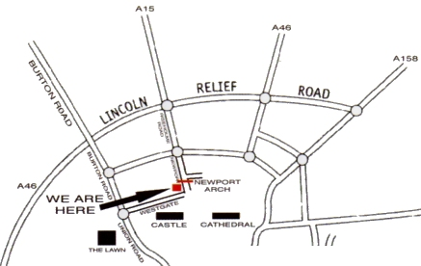
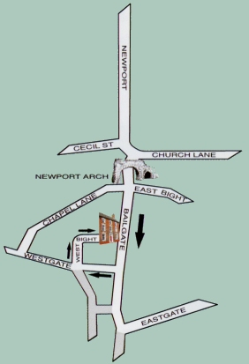

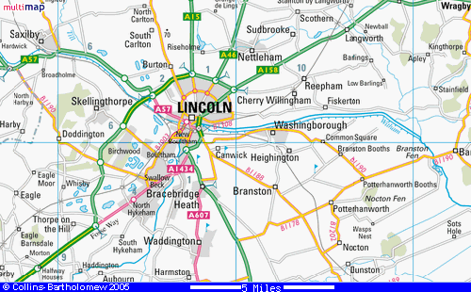

York, England – 23, St. Mary’s

England – York: Directions: See map below.

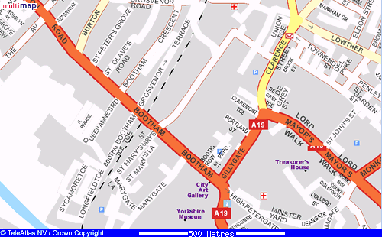

Amboise, France – Hotel la Breche

France - Amboise: Directions: Railway station S.N.C.F. at Amboise = 500m.
Tours - Saint-Pierre des Corps (TGV) = 20 kms. HighwayA10 - Exit N°18 - Direction Amboise and RN 152, and direction railway station.

